**Project 4: Analysing Music Records Sales using SQL**

Chinook is a fictional music record store based out of the USA. The store offers a wide range of music genres, from classic rock and jazz to modern indie and hip-hop. With a passion for music and a commitment to providing exceptional customer experiences, Chinook aims to be the go-to destination for music lovers.

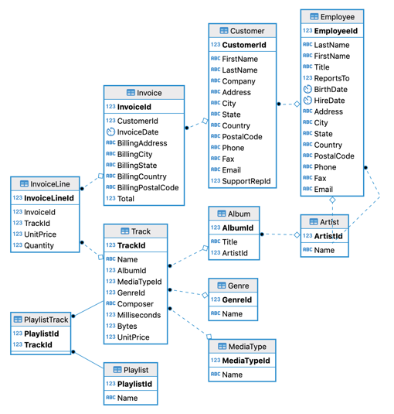

To achieve so, they have the following business objectives:

1. Establish Chinook as the premier destination for music records.
2. Provide a diverse selection of music genres to cater to a wide range of customer preferences.
3. Deliver excellent customer service to enhance the shopping experience.
4. Build a loyal customer base and foster long-term relationships through engagement and promotional events.

To drive its decisions through data, Chinook maintains a comprehensive database capturing various aspects of its business. The database includes information about different albums, music tracks, customers, sales transactions, and employees. Your task is to utilise your SQL skills to conduct data cleaning and analysis, enabling the extraction of valuable insights that will drive business growth and ensure long-term success.

Segment 1: Database - Tables, Columns, Relationships

* Identify the tables in the database and their respective columns.
* Determine the number of records in each table within the schema.
* Identify and handle any missing or inconsistent values in the dataset.
* Analyse the data types of the columns in each table to ensure they are appropriate for the stored data.
* Identify any duplicate records within the tables and develop a strategy for handling them.

Segment 2: Track/Album Analysis

* How many tracks does Chinook store have in total?
* Which tracks are the most popular among customers?
* What are the top-selling albums in the Chinook store?
* Which artist or album has the highest number of tracks in the store?
* Determine the number of tracks for each album and calculate the total duration of each album. Identify the albums that have the highest average track duration.
* How does the genre distribution vary among albums?

Segment 3: Customer Analysis

* Analyse customer demographics, purchase history, and preferences.
* How many unique customers are there in the Chinook store?
* What is the distribution of customers across different countries?
* Identify the average number of tracks purchased per customer for each genre.
* What is the average purchase value per customer?
* Which customers have made the highest number of purchases?

Segment 4: Support analysis

* What is the total sales revenue generated by each sales support agent?
* What is the average order value for each sales support agent?
* Is there any significant difference in sales performance between agents reporting to different managers?
* How does the hiring date of sales support agents impact their sales performance?

Segment 5: Sales Analysis

* What is the total revenue generated by the Chinook store?
* How does the revenue vary across different countries?
* Calculate the percentage of total sales contributed by each genre in the USA and identify the best-selling genres and artists.
* Evaluate sales performance over time to identify seasonal trends and peak periods.
* Determine the average transaction value and customer lifetime value to gauge business profitability.

Segment 6: SQL Concepts

* Use subqueries to find the top-selling tracks in the USA and identify their associated genres.0
* Implement joins to retrieve customer information along with their preferred genres and country of origin.
* Apply window functions to rank genres based on their sales performance in the USA.
* Create stored procedures to calculate the average revenue per sale for each genre in the USA.

Segment 7: Market Expansion and Advertising Strategy

* Recommend the three albums from the new record label that should be prioritised for advertising and promotion in the USA based on genre sales analysis.
* Identify high-value customers and develop personalised marketing strategies to nurture customer loyalty.
* Analyse the potential for expanding sales of different genres in other countries based on their sales performance in the USA.
* Determine the top-selling genres in countries other than the USA and identify any commonalities or differences.

Evaluation pointers:

* The tasks are correctly identified and executed.
* The solution output matches the expected output.
* The query is optimised and syntactically correct.
* Proper aliases are used
* If required any, appropriate comments are written.
* The code is written concisely with appropriate indentations.